Examples of Correlation Coefficient (r)

Below are graphs showing the different correlation coefficients (r values) above each one.
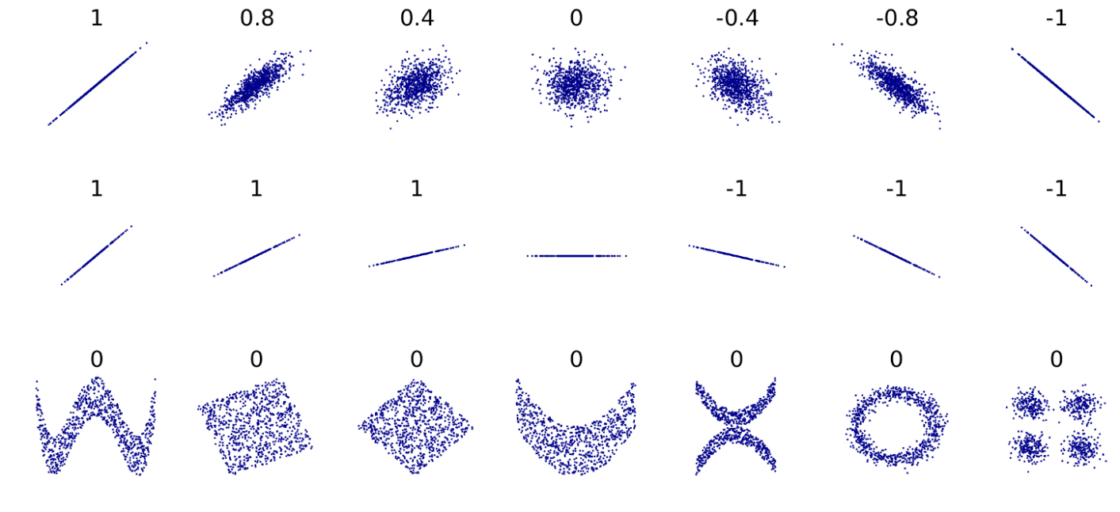

Source: http://upload.wikimedia.org/wikipedia/commons/d/d4/Correlation_examples2.svg

Separating Variables
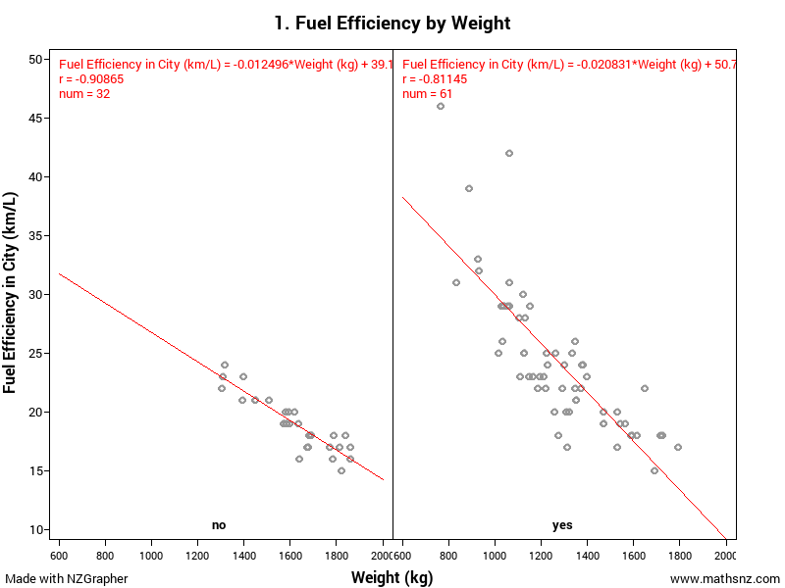
Teachers note: this is not a requirement of the standard, but it does round out the discussion nicely.

One of the things you can do to round out the discussion is separate out the data by a categorical variable to see if this is affecting the trend. You do this by choosing a variable in the ‘Subset’ section on NZGrapher. This gives the output on the right.

